2014-SK-01-EN Stickers
0 medium | I: easy | II: ---- | III: ---- | IV: ----

Answer Type: Multiple Choice Mandatory for: none

Body

Beaver Johnny put stickers on a picture of a fish bowl. He starts with grass, adds stones, a fish and a beaver.
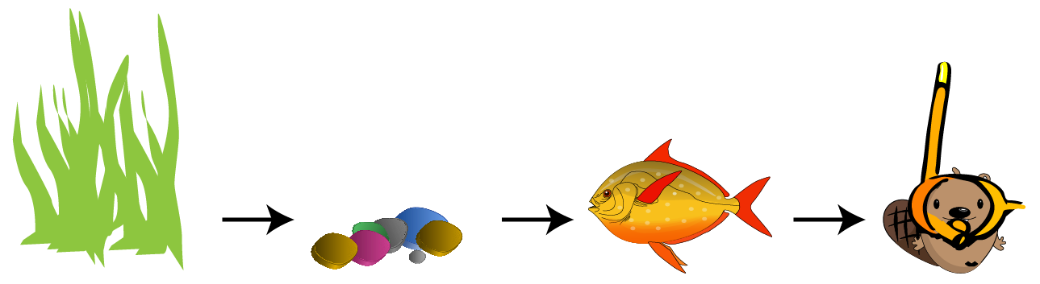

Question

What did the final picture look like?

Answer

A)  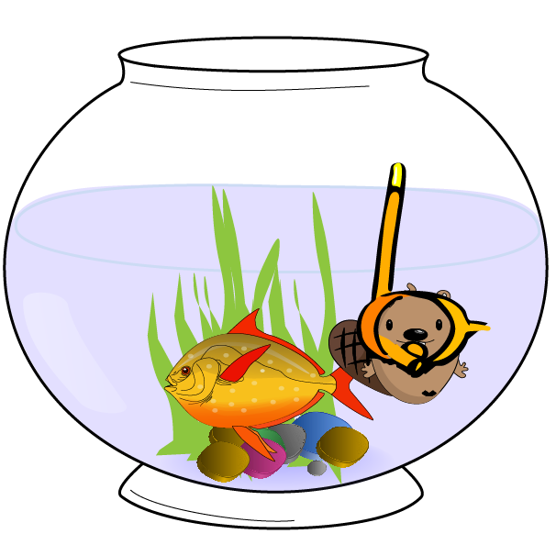 | 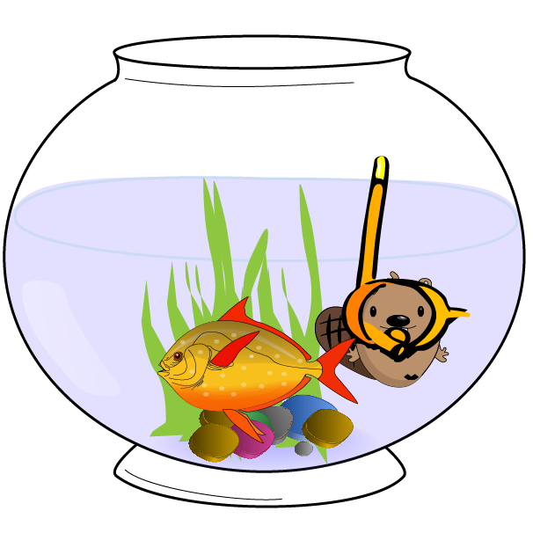  B)
C)  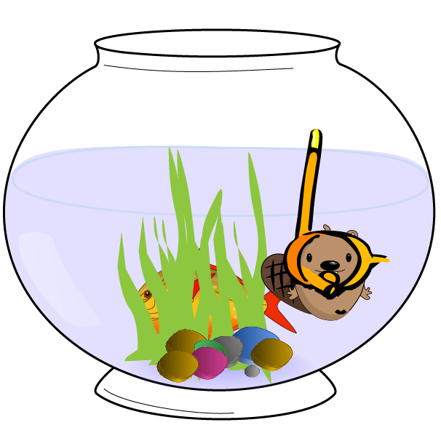 | D)  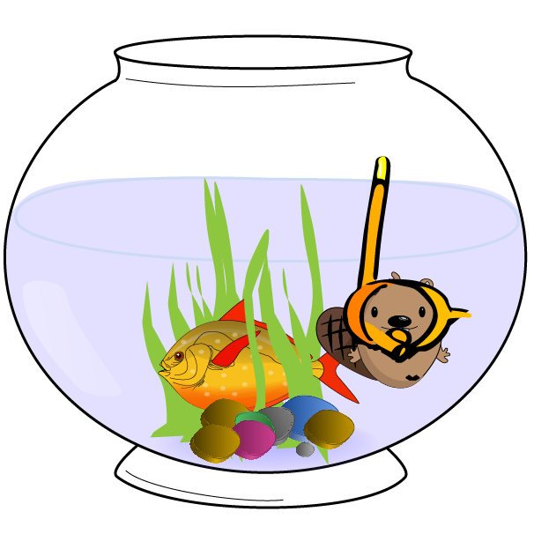

Explanation

The correct answer is A.
B is wrong because the beaver must be at the top. C is wrong because the fish should be above (in front) of the grass. D is obviously wrong because the fish swims through the grass.

It's informatics

The order of actions and their final result are among the most common things which informatics deals with. Moreover, understanding this particular task gives you useful knowledge for using graphical editors.

Keywords

order of actions, use of graphical editor

Websites

Internal Use

Wording

Comments

WG7 (Janez Demšar): Replaced the geometrical shapes with pictures, and painting with stickers. Changed the classification to medium for group 0, easy for 1.

Graphics

All graphics comes from the OpenClipart library.

Files

2014-SK-01-EN Robot painting.odt (this file)
2014-SK-01_all.svg (all pictures in one)
2014-SK-01_all.ai (Illustrator format, with artboards)
2014-SK-01_sequence.png
2014-SK-01_stickers-a.png
2014-SK-01_stickers-b.png
2014-SK-01_stickers-c.png
2014-SK-01_stickers-d.png

Authorship

Monika Gujberová, mgujberova@gmail.com , Slovakia.

License

Copyright © 2014 Bebras – International Contest on Informatics and Computer Fluency. This work is licensed under a Creative Commons Attribution-NonCommercial-ShareAlike 3.0 Unported License (CC BY-NC-SA 3.0). Visit: http://creativecommons.org/licenses/by-sa-sa/3.0/

